Saving Energy and Money With Electrical System Monitoring and Analysis

“The RS Alert/Monitoring System is the result of merging the analytics designs of RS, the software development of Systems Integration Plus, and NI CompactRIO embedded hardware. CompactRIO was chosen because of its durability, dependability, size, and ease of implementation. Additionally, the wide variety of tools and system support offered by NI LabVIEW system design software provided an effective foundation for our system development.” – Richman Surrey

Author: Richman Surrey

NI Products Used: NI CompactRIO Integrated Controller, NI 9201, 9255

Industry: Energy Management

The Challenge:
Knowing little information about electrical system efficiency and how it potentially costs businesses hundreds of thousands of dollars a year in energy overpayments, downtime, and untimely equipment failure.

The Solution:
Working with NI Alliance Partner Systems Integration Plus, Inc., and National Instruments to develop a proven proprietary alert and monitoring system that provides powerful electrical system predictive analytics to prevent energy waste and untimely equipment failure. Based on the results, Richman Surrey (RS) supplies solutions that reduce energy usage and eliminate excessive payments to utility companies.

Dramatically increasing electrical costs for commercial businesses inspired RS to develop equipment and services that provide the most effective and energy-efficient electrical systems. These solutions result in substantial reductions in operating costs, with a typical investment payback of 12 to 24 months.

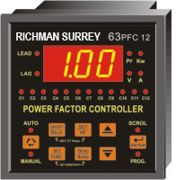
Figure 1. RS Controller

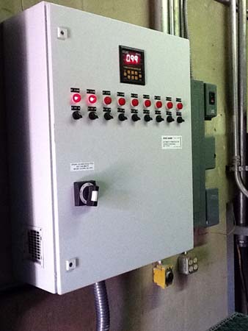
Figure 2. RS Power Management Unit

The RS power management unit (PMU) boosts a facility’s electrical system efficiency to more than 95 percent (measured as power factor) by using and enhancing a proven base technology for the US market that is installed in more than 7,000 European and Asian commercial and manufacturing facilities. This “breakthrough technology” uniquely incorporates a dynamic controller that manages banks of capacitors to ensure that the electrical system operates at peak efficiency at all times. Peak efficiency results in lower energy bills.

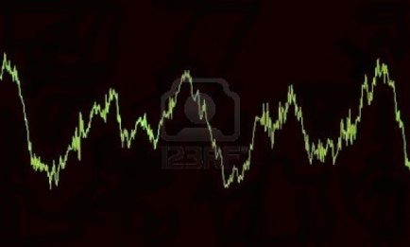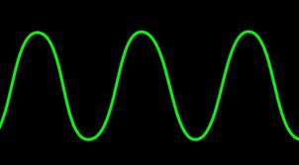
Figure 3. Harmonic Distorted Sine Wave Figure 4. Clean Sine Wave

Another key solution helps eliminate harmonic distortion, which is a corruption of the electrical sine wave caused by computers, lighting, variable-speed drives, solar installations, office equipment, or single-phase devices on a three-phase system. Eliminating harmonic distortion means lower energy bills as well as reduced maintenance and replacement of electrical equipment.

After developing the above solutions, RS realized the importance of not only initially identifying problems but also conducting ongoing analytical monitoring because factors within an electrical system are continually changing.

System Development
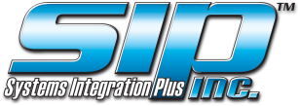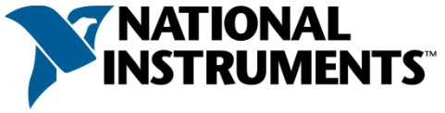

The RS Alert/Monitoring System is the result of merging the analytics designs of RS, the software development of Systems Integration Plus, and NI CompactRIO embedded hardware. CompactRIO was chosen because of its durability, dependability, size, and ease of implementation. Additionally, the wide variety of tools and system support offered by NI LabVIEW system design software provided an effective foundation for our system development.

The RS Alert/Monitoring System not only monitors key components of the entire electrical system, but it can incorporate a wide variety of wireless sensors to track specific equipment performance, temperature, lumens, and gas leakage. A well-designed system provides the information for power factor and harmonic distortion solutions, as well as leading indicators of equipment failure, to avoid costly and untimely shutdowns.

A powerful unique feature of the RS Alert/Monitoring System is the alert process that we use to compare sensor readings to a range of operating parameters and notify assigned personnel of the exceptions. This ensures that exceptions are always discovered and significantly reduces personnel monitoring time, thus increasing efficiency. The system uses wireless technology with alerts and dashboards transferred via Internet. Trends are stored and displayed graphically for easy analysis. To view an RS Alert/Monitoring System live example, follow these instructions:
- Visit richmansurrey.com.
- Click Data Center in the left menu.
- Click Monitoring center.
- Click LOGIN.
- Enter rstest in the User Name field.
- Enter rstest in the Password field.
- Click Tanner Gardens Properties Inc.
- Click TG.
- Click Tanner Gardens Phoenix.
- Click View Device: 74-DE-2B-A4-15-C0.
- Click Trends. In the new window, you can:
  - View various graphs by checking boxes at the top of the page.
  - Scroll to the bottom of the page to see averages and energy savings.
  - Note that energy savings are based on change from baseline values for the power factor.

Note that this location has no corrective solutions installed, but monitoring reflects that they are needed.
The System in Action
The installation of the RS Alert/Monitoring System at Tanner Gardens in Phoenix is part of an in-process Housing and Urban Development prototype project to increase energy efficiency and reduce operating costs at low-income retirement facilities. There were a wide variety of retrofit energy-efficient modifications to the facility included in the construction project, such as lighting and window updates; correction of harmonic distortion; improvements in electrical system efficiency (power factor); and installation of a solar reflective roof, programmable thermostats, and new refrigerators. The RS system was installed to provide analytics on the need for and impact of the various solutions to the operating costs of the facility. So far, the trend information on the graphs clearly shows the potential positive impact of correcting the power factor and harmonic distortion.
Trend Classifications | High/Low Trend Values | Action From Analytics
Power Factor, Temperature, and Kilovolt-Ampere Reactive | From a high of .98 to a low of .32 when heating equipment is operating during colder days | Install a sensor on the heating system to pinpoint the problem equipment.  Installing a PMU significantly reduces the loss of energy efficiency and lowers electricity costs.
Total Harmonic Distortion—Current | From a high of 14% to a low of 9% when a 7% level typically results in a waste of 10% in energy costs | Installing harmonic distortion correction equipment significantly reduces energy waste.
Voltage | From a high of 123 V to a low of 121 V, this indicates stability in the voltage | No further action at this time is necessary—continue to monitor.
Amps and Temperature | Trends for November and December show a high of 99 A to a low of 35 A and an increase to a high of 64 A; these reflect the changing amp usage of air conditioning/heating units | Increasing system efficiency (power factor) and reducing harmonic distortion decreases the current needed to operate these systems and lowers energy payments.
Table 1. Measuring Leads to Benefits
Having the RS Alert/Monitoring System in place at the beginning of the project also provides an operation baseline from which the impact of energy consumption caused by implementing energy-efficient modifications can be measured. By continually monitoring the electrical system and equipment, alerts noting that elements are outside parameters provide leading indicators that maintenance is needed or that equipment needs to be repaired or replaced. These leading indicators help us take corrective action before equipment failure or costly downtime occurs. Using the RS Alert/Monitoring System developed with CompactRIO hardware and LabVIEW software, we are able to clearly identify energy-waste issues that can now be resolved, saving our clients money and resources.
A National Instruments Alliance Partner is a business entity independent from National Instruments and has no agency, partnership, or joint-venture relationship with National Instruments.
Author Information:
Richman Surrey
Email: rs@richmansurrey.com

